**1.Introduction**

The T20 World Cup is a highly anticipated cricket tournament that draws in fans from all over the world. This major international event brings together the best teams from across the globe to compete for the ultimate prize. Scheduled to take place in 2022, the tournament promises to be an exciting and action-packed event that cricket enthusiasts are eagerly awaiting.

As one of the most prestigious cricket tournaments in the world, the T20 World Cup is a showcase of the sport's finest talent. The competition is fierce, and the stakes are high, making it a must-see event for any cricket fan. With teams from all corners of the globe vying for the top spot, the tournament promises to be a thrilling display of skill, strategy, and sportsmanship.

Whether you're a die-hard cricket fan or simply enjoy watching the sport, the T20 World Cup is an event not to be missed. So mark your calendars and get ready for an unforgettable experience as the world's best cricket teams battle it out for glory in 2022.

As the tournament draws closer, there is likely to be a lot of analysis and discussion about the teams, players, and the tournament itself. In this analysis, we will take a closer look at some of the key factors that could impact the outcome of the tournament. In this analysis, we will thoroughly examine the performance of each team in the lead-up to the tournament, identify the key players to watch out for, delve into the tournament format and conditions, and explore the rich history of the T20 World Cup. Our ultimate goal is to provide fans with a comprehensive overview of what they can expect from this highly anticipated event.

## 1.1PROJECT DESCRIPTION:

A T20 World Cup analysis project for the upcoming 2022 tournament could involve a detailed analysis of the tournament and its participants using various data sources and analytical techniques. The project could include the following components:

The first step in the project would involve collecting relevant data related to the tournament, such as team and player statistics, historical performance data, tournament format, weather conditions, and pitch conditions.

Once the data has been collected, it would need to be cleaned and preprocessed. This could involve removing missing values, transforming the data into a consistent format, and standardizing the data.

After the data has been cleaned and preprocessed, an exploratory data analysis could be conducted to gain insights into the data. This could involve visualizing the data using charts and graphs, identifying trends and patterns in the data, and performing statistical tests to determine the significance of the findings.

Machine learning techniques could be used to build predictive models for the tournament. This could involve using regression models to predict team performance, classification models to predict the winners of each match, and clustering models to group teams based on their performance.

The findings of the analysis could be presented in a visually appealing and easy-to-understand manner using data visualization techniques. This could include creating interactive dashboards, charts, and graphs to communicate the insights gained from the analysis.

Finally, the project could conclude with a summary of the findings and recommendations for teams, players, and fans. This could include insights into the strengths and weaknesses of each team, predictions for the tournament, and recommendations for players to watch out for.

Overall, a T20 World Cup analysis project for 2022 could provide valuable insights into the tournament and its participants, using a combination of data analysis and machine learning techniques.

## 2.LITERATURE SURVEY:

A literature survey of the Indian house prices visualization project can provide insights into the existing research and studies on the real estate market in India and data visualization techniques. Some of the key findings from the literature survey are:

1.Real Estate Market in India: The Indian real estate market is highly complex, with a range of factors affecting property prices. These factors include location, infrastructure, demographics, economic conditions, and government policies.

Data Sources: Various data sources are available for analyzing the real estate market in India, including government databases, surveys, and real estate websites. These sources provide data on house prices, property types, locations, amenities, and market trends.

2.Data Visualization Techniques: Data visualization is an important tool for analyzing and communicating complex data. Different visualization techniques, such as heat maps, charts, and graphs, can be used to present the data in an engaging and informative way.

3.Existing Visualization Tools: Several existing tools and platforms provide data visualizations of the real estate market in India. These tools include property portals, government websites, and private data analytics firms. However, these tools are often limited in terms of the data available or the level of interactivity provided.

4.Challenges in Data Visualization: While data visualization is a powerful tool for communicating complex data, it also presents several challenges. These challenges include selecting the appropriate visualization technique, ensuring data accuracy and integrity, and providing a user-friendly interface.

Overall, the literature survey highlights the importance of data visualization in

understanding the real estate market in India. The Indian house prices visualization project can build on the existing research and studies, providing an interactive platform that offers a comprehensive view of the real estate market. By addressing the challenges in data visualization and incorporating user feedback, the project has the potential to improve the transparency of the real estate market and help users make informed decisions.

## TECHNOLOGIES AND MODULES USED

**(a)PANDAS**

pandas is a Python package that provides fast, flexible, and expressive data structures designed to make working with "relational" or "labeled" data both easy and intuitive. It aims to be the fundamental high-level building block for doing practical, real world data analysis in Python. Additionally, it has the broader goal of becoming the most powerful and flexible open-source data analysis / manipulation tool available in any language. It is already well on its way towards this goal.

Here are just a few of the things that pandas does well:

* a)Easy handling of missing data (represented as NaN, NA, or NaT) in floating point as well as non-floating-point data
* a)Size mutability: columns can be inserted and deleted from DataFrame and higher dimensional objects
* c.Automatic and explicit data alignment: objects can be explicitly aligned to a set of labels, or the user can simply ignore the labels and let Series, DataFrame, etc. automatically align the data for you in computations
* d.Powerful, flexible group by functionality to perform split-apply-combine operations on data sets, for both aggregating and transforming data
* e.Make it easy to convert ragged, differently-indexed data in other Python and NumPy data structures into DataFrame objects
* f.Intelligent label-based slicing, fancy indexing, and subsetting of large data sets
* Intuitive merging and joining data sets
* Flexible reshaping and pivoting of data sets
* Hierarchical labeling of axes (possible to have multiple labels per tick)
* Robust IO tools for loading data from flat files (CSV and delimited), Excel files, databases, and saving/loading data from the ultrafast HDF5 format
* Time series-specific functionality: date range generation and frequency conversion, moving window statistics, date shifting and lagging

## (b)NUMPY

NumPy is a library for the Python programming language, adding support for large, multi-dimensional arrays and matrices, along with a large collection of high-level mathematical functions to operate on these arrays.The ancestor of NumPy, Numeric, was originally created by Jim Hugunin with contributions from several other developers. In 2005, Travis Oliphant created NumPy by incorporating features of the competing Numarray into Numeric, with extensive modifications. NumPy is open-source software and has many contributors. NumPy is a NumFOCUS fiscally sponsored project.

NumPy targets the CPython reference implementation of Python, which is a non- optimizing bytecode interpreter. Mathematical algorithms written for this version of Python often run much slower than compiled equivalents. NumPy addresses the slowness problem partly by providing multidimensional arrays and functions and operators that operate efficiently on arrays; using these requires rewriting some code, mostly inner loops, using NumPy.

Using NumPy in Python gives functionality comparable to MATLAB since they are both interpreted, and they both allow the user to write fast programs as long as most operations work on arrays or matrices instead of scalars. In comparison, MATLAB boasts a large number of additional toolboxes, notably Simulink, whereas NumPy is intrinsically integrated with Python, a more modern and complete programming language. Moreover, complementary Python packages are available; SciPy is a library that adds more MATLAB-like functionality and Matplotlib is a plotting package that provides MATLAB-like plotting.

Internally, both MATLAB and NumPy rely on BLAS and LAPACK for efficient linear algebra computations.

Python bindings of the widely used computer vision library OpenCV utilize NumPy arrays to store and operate on data. Since images with multiple channels are simply represented as three-dimensional arrays, indexing, slicing or masking with other arrays are very efficient ways to access specific pixels of an image. The NumPy array as universal data structure in OpenCV for images, extracted feature points, filter kernels and many more vastly simplifies the programming workflow and debugging.

## The ndarray data structure

The core functionality of NumPy is its "ndarray", for n-dimensional array, data structure. These arrays are strided views on memory. In contrast to Python's built- in list data structure, these arrays are homogeneously typed: all elements of a single array must be of the same type.

Such arrays can also be views into memory buffers allocated by C/C++, Cython, and Fortran extensions to the CPython interpreter without the need to copy data around, giving a degree of compatibility with existing numerical libraries. This functionality is exploited by the SciPy package, which wraps a number of such libraries (notably BLAS and LAPACK). NumPy has built-in support for memory-mapped ndarrays

## (c)FOLIUM

Folium builds on the data wrangling strengths of the Python ecosystem and the mapping strengths of the Leaflet.js library. Manipulate your data in Python, then visualize it in a Leaflet map via folium.

Folium makes it easy to visualize data that’s been manipulated in Python on an interactive leaflet map. It enables both the binding of data to a map for choropleth

visualizations as well as passing rich vector/raster/HTML visualizations as markers on the map.

The library has a number of built-in tilesets from OpenStreetMap, Mapbox, and Stamen, and supports custom tilesets with Mapbox or Cloudmade API keys. folium supports both Image, Video, GeoJSON and TopoJSON overlays.

## (e)PLOTLY

plotly.py is an interactive, open-source, and browser-based graphing library for Python

Built on top of plotly.js, plotly.py is a high-level, declarative charting library. plotly.js ships with over 30 chart types, including scientific charts, 3D graphs, statistical charts, SVG maps, financial charts, and more.

plotly.py is MIT Licensed. Plotly graphs can be viewed in Jupyter notebooks, standalone HTML files, or hosted online using Chart Studio Cloud.

Plotly.py (also known as the plotly module) includes some exciting new features and changes, including a switch to “offline” mode by default, the inclusion of Plotly Express as the recommended entry point into the library, and a new rendering framework compatible with not only Jupyter notebooks but other notebook systems such as Colab, Azure and Kaggle notebooks, as well as popular IDEs such as PyCharm, VSCode, Spyder and others.

## 3.HARDWARE AND SOFTWARE REQUIREMENTS MINIMUM HARDWARE REQUIREMENTS

* Processors: Intel® Core™ i3 or AMD Ryzen 3250u CPU
* RAM: 2GB of on-board system memory
* Disk Space: 1-2GB of Hard Drive space
* Network: 1+Mbps Internet Connectivity

## RECOMMENDED HARDWARE REQUIREMENTS

* Processors: Intel® Core™ i5 @2.60GHz, new-gen Xeon® processor @2.30 GHz or AMD Ryzen 5 CPUs running at higher frequency
* RAM: 4GB of system memory from any decent manufacturer
* Disk space: 2-3GB of Hard Drive
* Network: 4 Mbps Internet Connectivity

## MINIMUM SOFTWARE REQUIREMENTS

* Operating System: Windows 8.1, Linux 64-bit Ubuntu 18.04+ or Mac OS X 10.11 & up
* IDE: PyCharm Community Edition 2019+/ Jupyter Notebook
* Browser: Google Chrome 95+

## RECOMMENDED SOFTWARE REQUIREMENTS

* Operating System: Windows 10 Official, Mac OS 10.12.6, or Linux/Ubuntu 20.04
* IDE: PyCharm Community Edition 2021/ Jupyter Notebook
* Browser: Google Chrome 97

## 4.DESIGN

## 

## 

## 

## 

**5.IMPLEMENTATION**

## 5.1 SOURCE FILES

## 1. Importing the necessary Python libraries and the dataset:

## 

**2. The number of matches won by each team in the world cup:**

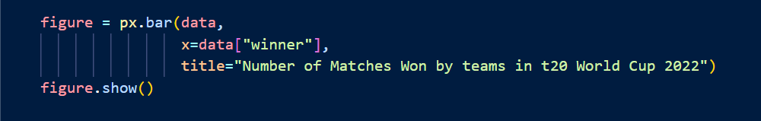

**3.** **the number of matches won by batting first or second in the t20 world cup 2022:**

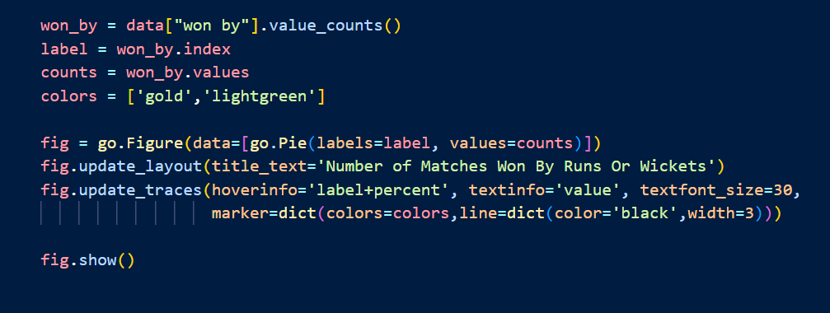

**4**. **the toss decisions by teams in the world cup:**

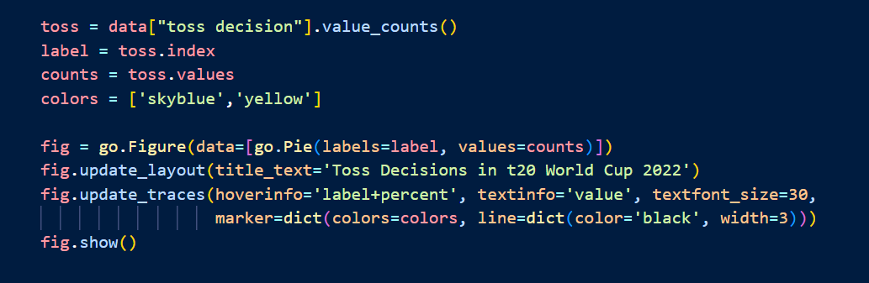

**5. the top scorers in the t20 world cup 2022:**

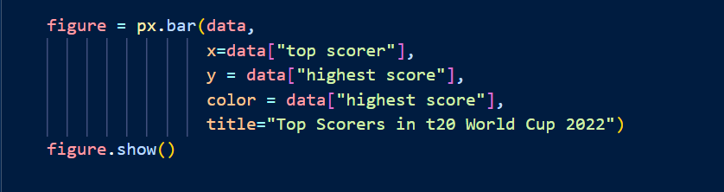

**6. the number of player of the match awards in the world cup:**

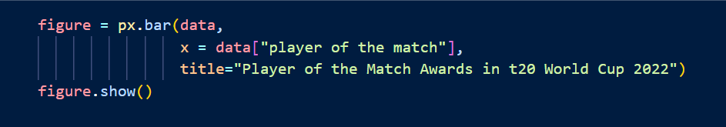

**7. the bowlers with the best bowling figures at the end of the matches:**

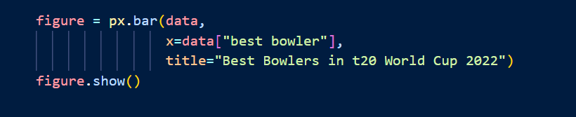

**8. compare the runs scored in the first innings and second innings in every stadium of the t20 world cup 2022:**

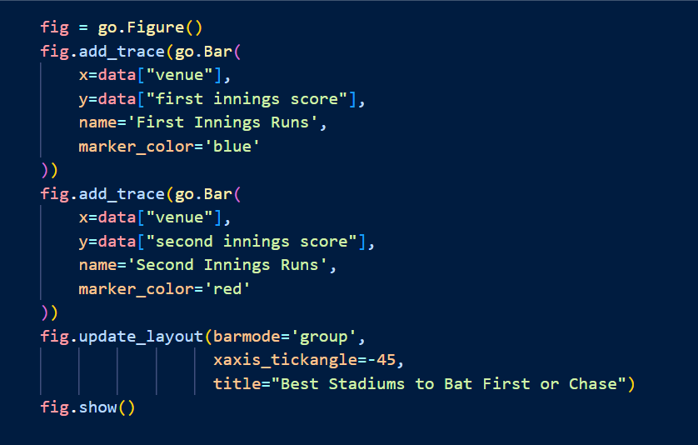

**9. compare the number of wickets lost in the first innings and second innings in every stadium of the t20 world cup 2022:**

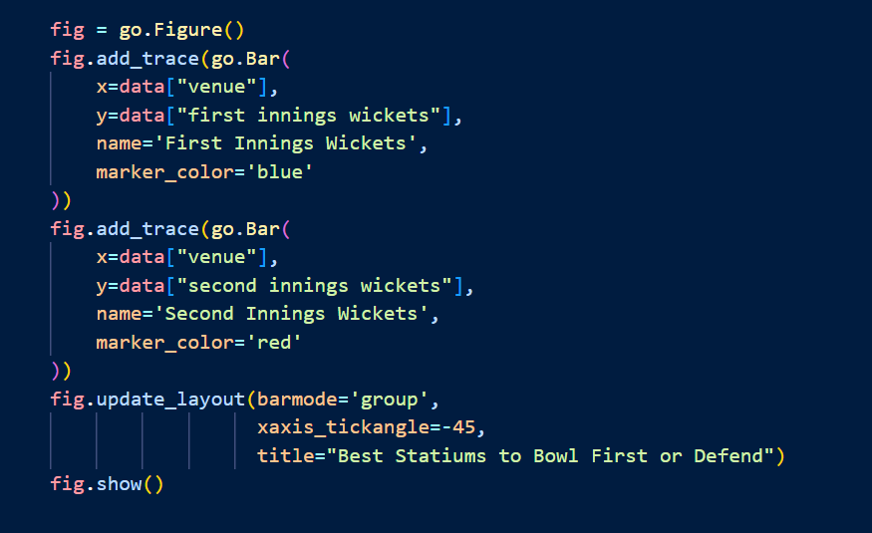**6. SCREENSHOTS**

**1.**

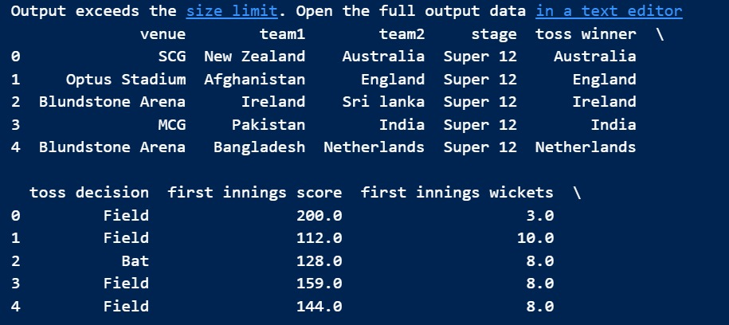

**2.**

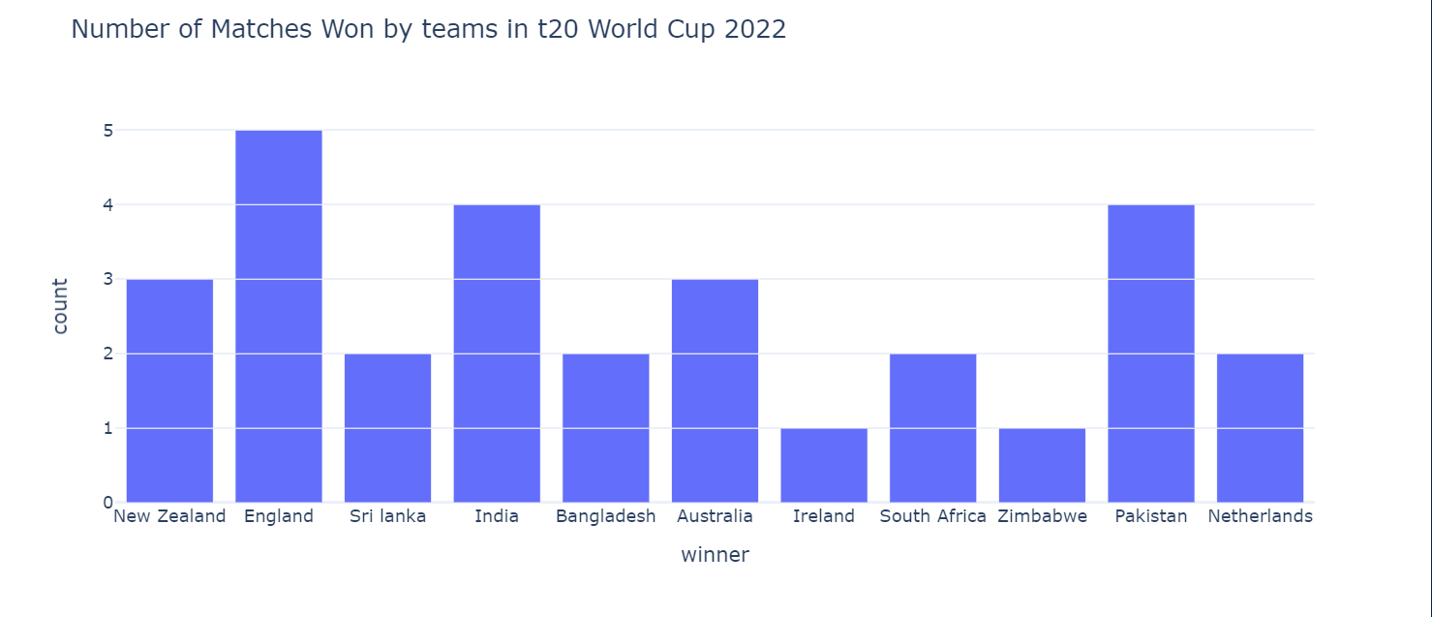

As England won the t20 world cup 2022, England won five matches. And Both Pakistan and India won 4 matches.

**3.**

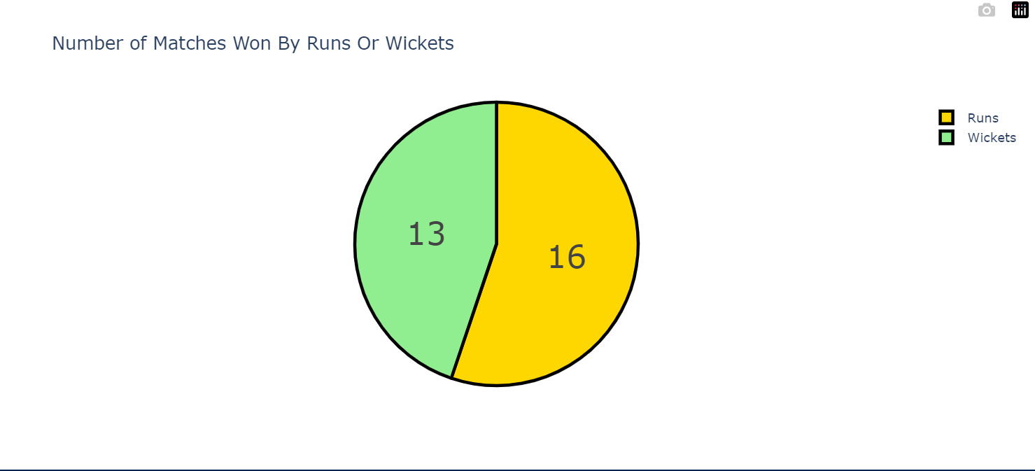

So in the t20 world cup 2022, 16 matches were won by batting first, and 13 matches were won by chasing.

**4.**

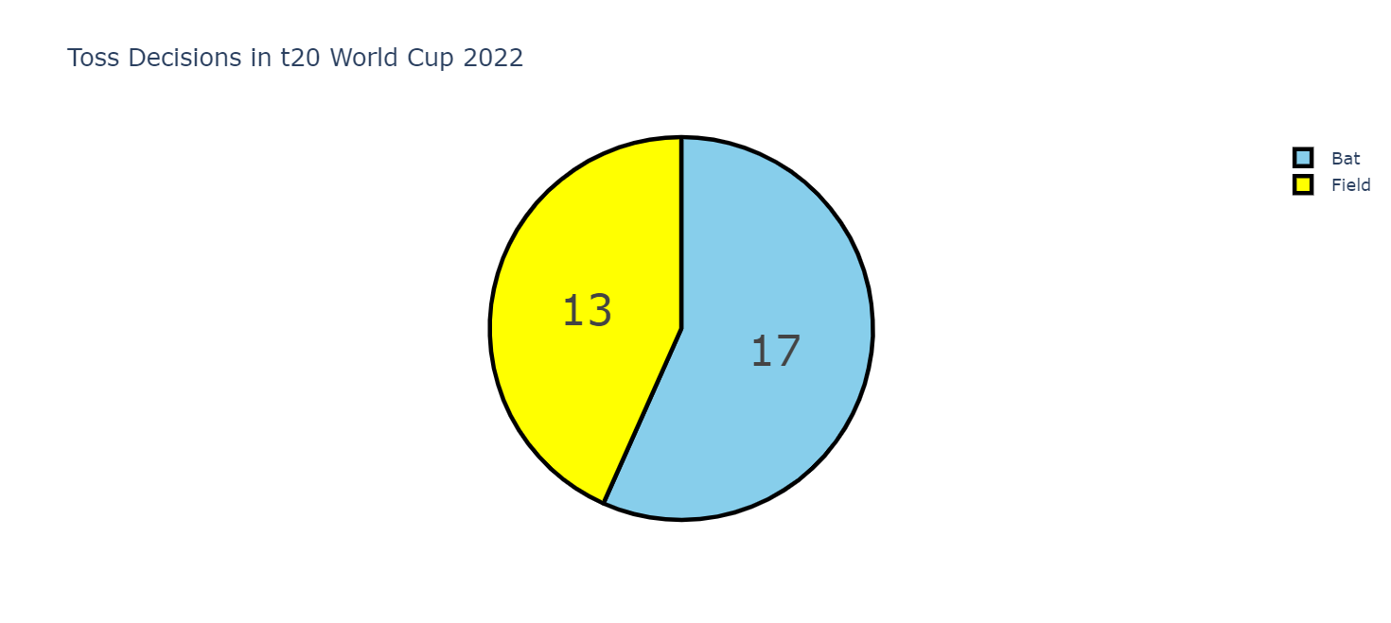

So in 17 matches, the teams decided to bat first, and in 13 matches, the teams chose to field first.

**5.**

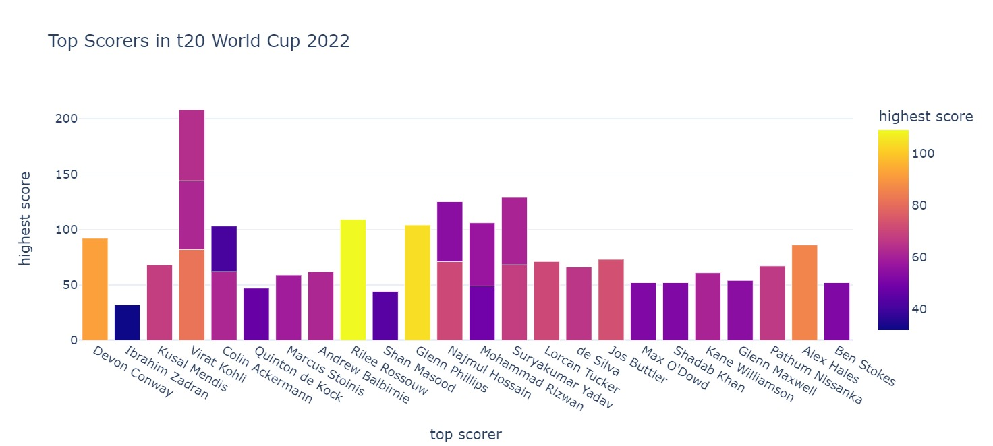

So, Virat Kohli scored the highest in 3 matches. Undoubtedly, he was the best batsman in the t20 world cup 2022.

**6.**

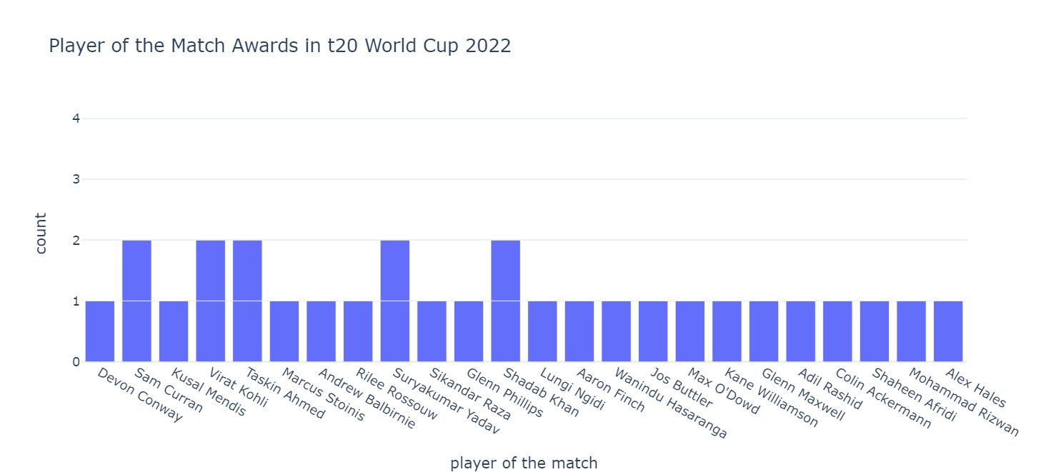

Virat Kohli, Sam Curran, Taskin Ahmed, Suryakumar Yadav, and Shadab Khan got the player of the match in 2 matches. No player got the player of the match award in more than two matches.

**7.**

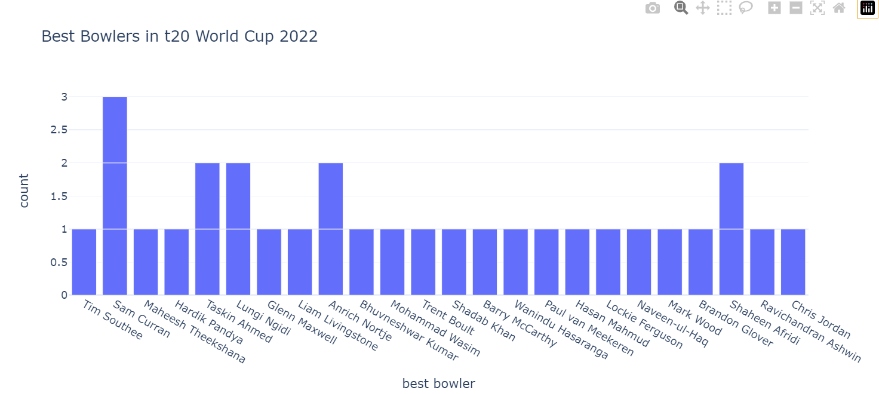

Sam Curran was the only best bowler in 3 matches. Undoubtedly, he deserved to be the player of the tournament.

**8.**

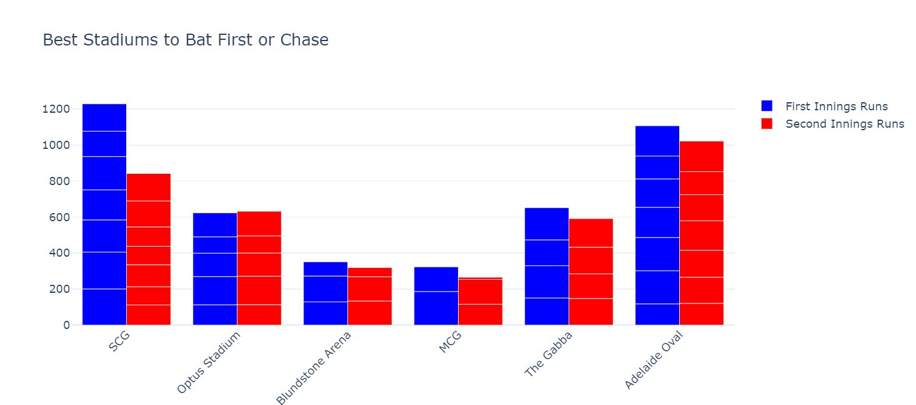

So SCG was the only stadium in the world cup that was best for batting first. Other stadiums didn’t make much difference while batting first or chasing.

**9.**

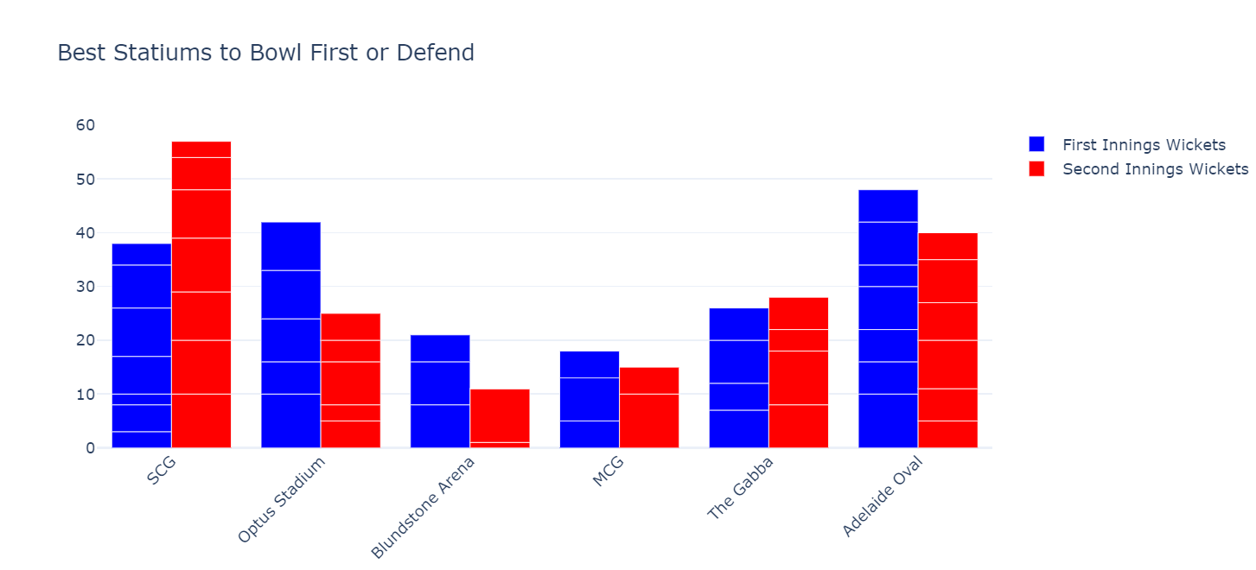

SCG was the best stadium to bowl while defending the target. While the Optus Stadium was the best stadium to bowl first.

## 7.CONCLUSION

In conclusion, a T20 World Cup analysis project for 2022 could provide valuable insights into the tournament and its participants. By collecting and analyzing relevant data using a combination of statistical and machine learning techniques, the project could help identify the factors that are likely to impact the tournament's outcome, such as team and player performance, weather and pitch conditions, and historical trends.

The project could also provide recommendations for teams, players, and fans, based on the insights gained from the analysis. This could include recommendations on strategies for teams to improve their performance, players to watch out for, and predictions for the tournament's outcome.

## Undertaking a T20 World Cup analysis project for 2022 would prove to be a valuable endeavor for those who are keenly interested in the tournament and its participants. By utilizing data-driven analysis, this project has the potential to provide insightful recommendations that can inform decisions and strategies for teams, players, and fans alike.

## The project would offer a comprehensive analysis of the tournament, including the performance of individual players and teams, their strengths and weaknesses, and the overall trends that emerge throughout the competition. This information can be used to develop winning strategies, identify areas for improvement, and make informed decisions about team selection and player development.

## Moreover, the project would be an excellent resource for fans who want to stay up-to-date with the latest developments in the tournament. By providing detailed insights and analysis, fans can gain a deeper understanding of the game and appreciate the skills and tactics of their favorite players and teams.

## In conclusion, a T20 World Cup analysis project for 2022 is a valuable undertaking that can benefit all stakeholders in the tournament. With its data-driven insights and recommendations, this project has the potential to inform decisions and strategies that can lead to success on the field and a more enjoyable experience for fans.

1. England won the most number of matches.
2. Virat Kohli scored highest in the most number of matches.
3. Sam Curran was the best bowler in the most number of matches.
4. More teams won by batting first.
5. More teams decided to bat first.
6. SCG was the best stadium to bat first.
7. SCG was the best stadium to defend the target in the World Cup.
8. The Optus Stadium was the best stadium to bowl first

## 8.FUTURE ENHANCEMENTS

Some potential future enhancements for a T20 World Cup analysis project for 2022 could include:

* Incorporating more data sources: The project could be enhanced by incorporating more data sources, such as social media data, to gain additional insights into the tournament and its participants.
* Using advanced machine learning techniques: The project could be enhanced by using more advanced machine learning techniques, such as deep learning, to improve the accuracy of the predictive models.
* Real-time updates: The project could be enhanced by incorporating real-time updates during the tournament, so that the analysis can be adjusted based on the latest data.
* Interactive dashboards: The project could be enhanced by creating more interactive dashboards that allow users to explore the data and gain insights on their own.
* Player-specific analysis: The project could be enhanced by providing more detailed analysis on individual players, such as their batting and bowling strengths and weaknesses.
* Collaborative analysis: The project could be enhanced by incorporating collaboration features that allow multiple users to work on the analysis together and share their insights.
* Overall, there are many ways to enhance a T20 World Cup analysis project for 2022, depending on the needs and goals of the project. By incorporating additional data sources, using advanced techniques, and providing more detailed analysis, the project could provide even more valuable insights for teams, players, and fans.

## 9.REFERENCES

**DATASET:**

https://www.novypro.com/project/data-analysis-of-t20-world-cup-cricket-data-2022-

**REFERENCES:**

**PLOTLY:**

* + <https://www.youtube.com/watch?v=BTh9FtmYY9Q>
  + <https://plotly.com/python/>
  + <https://github.com/plotly/plotly.py>
  + [https://towardsdatascience.com/cheat-codes-to-better-visualisations-with-plotly-](https://towardsdatascience.com/cheat-codes-to-better-visualisations-with-plotly-express-21caece3db01) [express-21caece3db01](https://towardsdatascience.com/cheat-codes-to-better-visualisations-with-plotly-express-21caece3db01)

**FOLIUM:**

* + <https://python-visualization.github.io/folium/>
  + <https://github.com/python-visualization/folium>
  + [https://towardsdatascience.com/creating-a-simple-map-with-folium-and-python-](https://towardsdatascience.com/creating-a-simple-map-with-folium-and-python-4c083abfff94) [4c083abfff94](https://towardsdatascience.com/creating-a-simple-map-with-folium-and-python-4c083abfff94)
  + <https://medium.com/datasciencearth/map-visualization-with-folium-d1403771717>
  + [https://www.geeksforgeeks.org/python-plotting-google-map-using-folium-](https://www.geeksforgeeks.org/python-plotting-google-map-using-folium-package/) [package/](https://www.geeksforgeeks.org/python-plotting-google-map-using-folium-package/)
  + <https://www.youtube.com/watch?v=t9Ed5QyO7qY>